Note: I’m not sure on where this will be looked at. Therefore, I’ll turn off my EC2 instance to avoid getting charged.

Please find below screenshots that should be as valid as the direct link.

If you still find that live link is necessary please email/text me so I can turn on the instance and send you the link.

Proof –

Github link: <https://github.com/lmartins18/devops-lab-3-task>

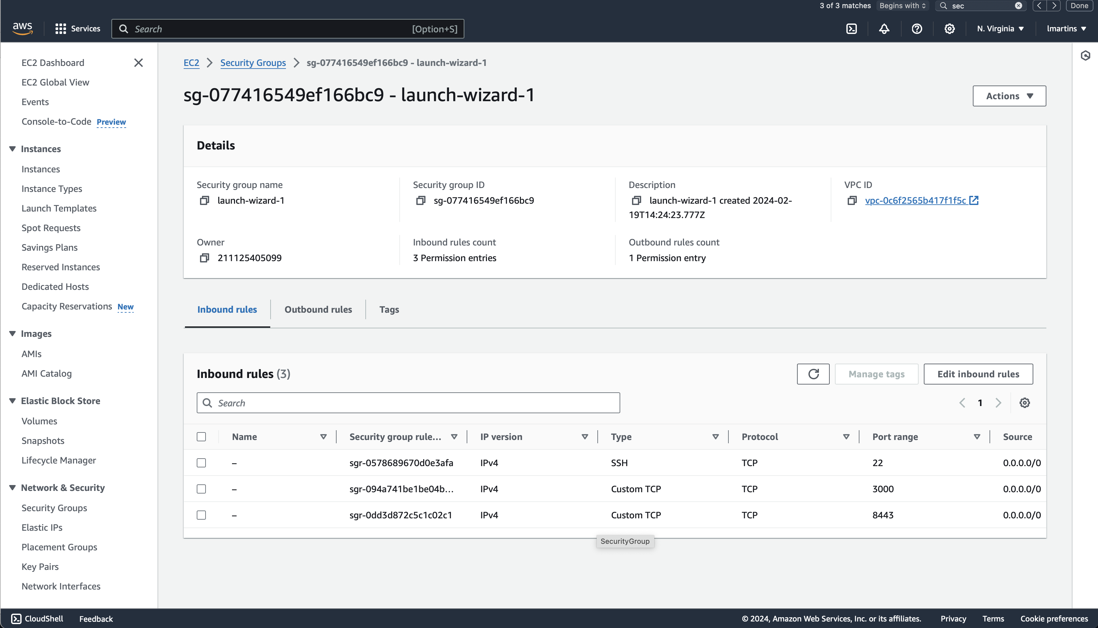

Security group with new https rule.

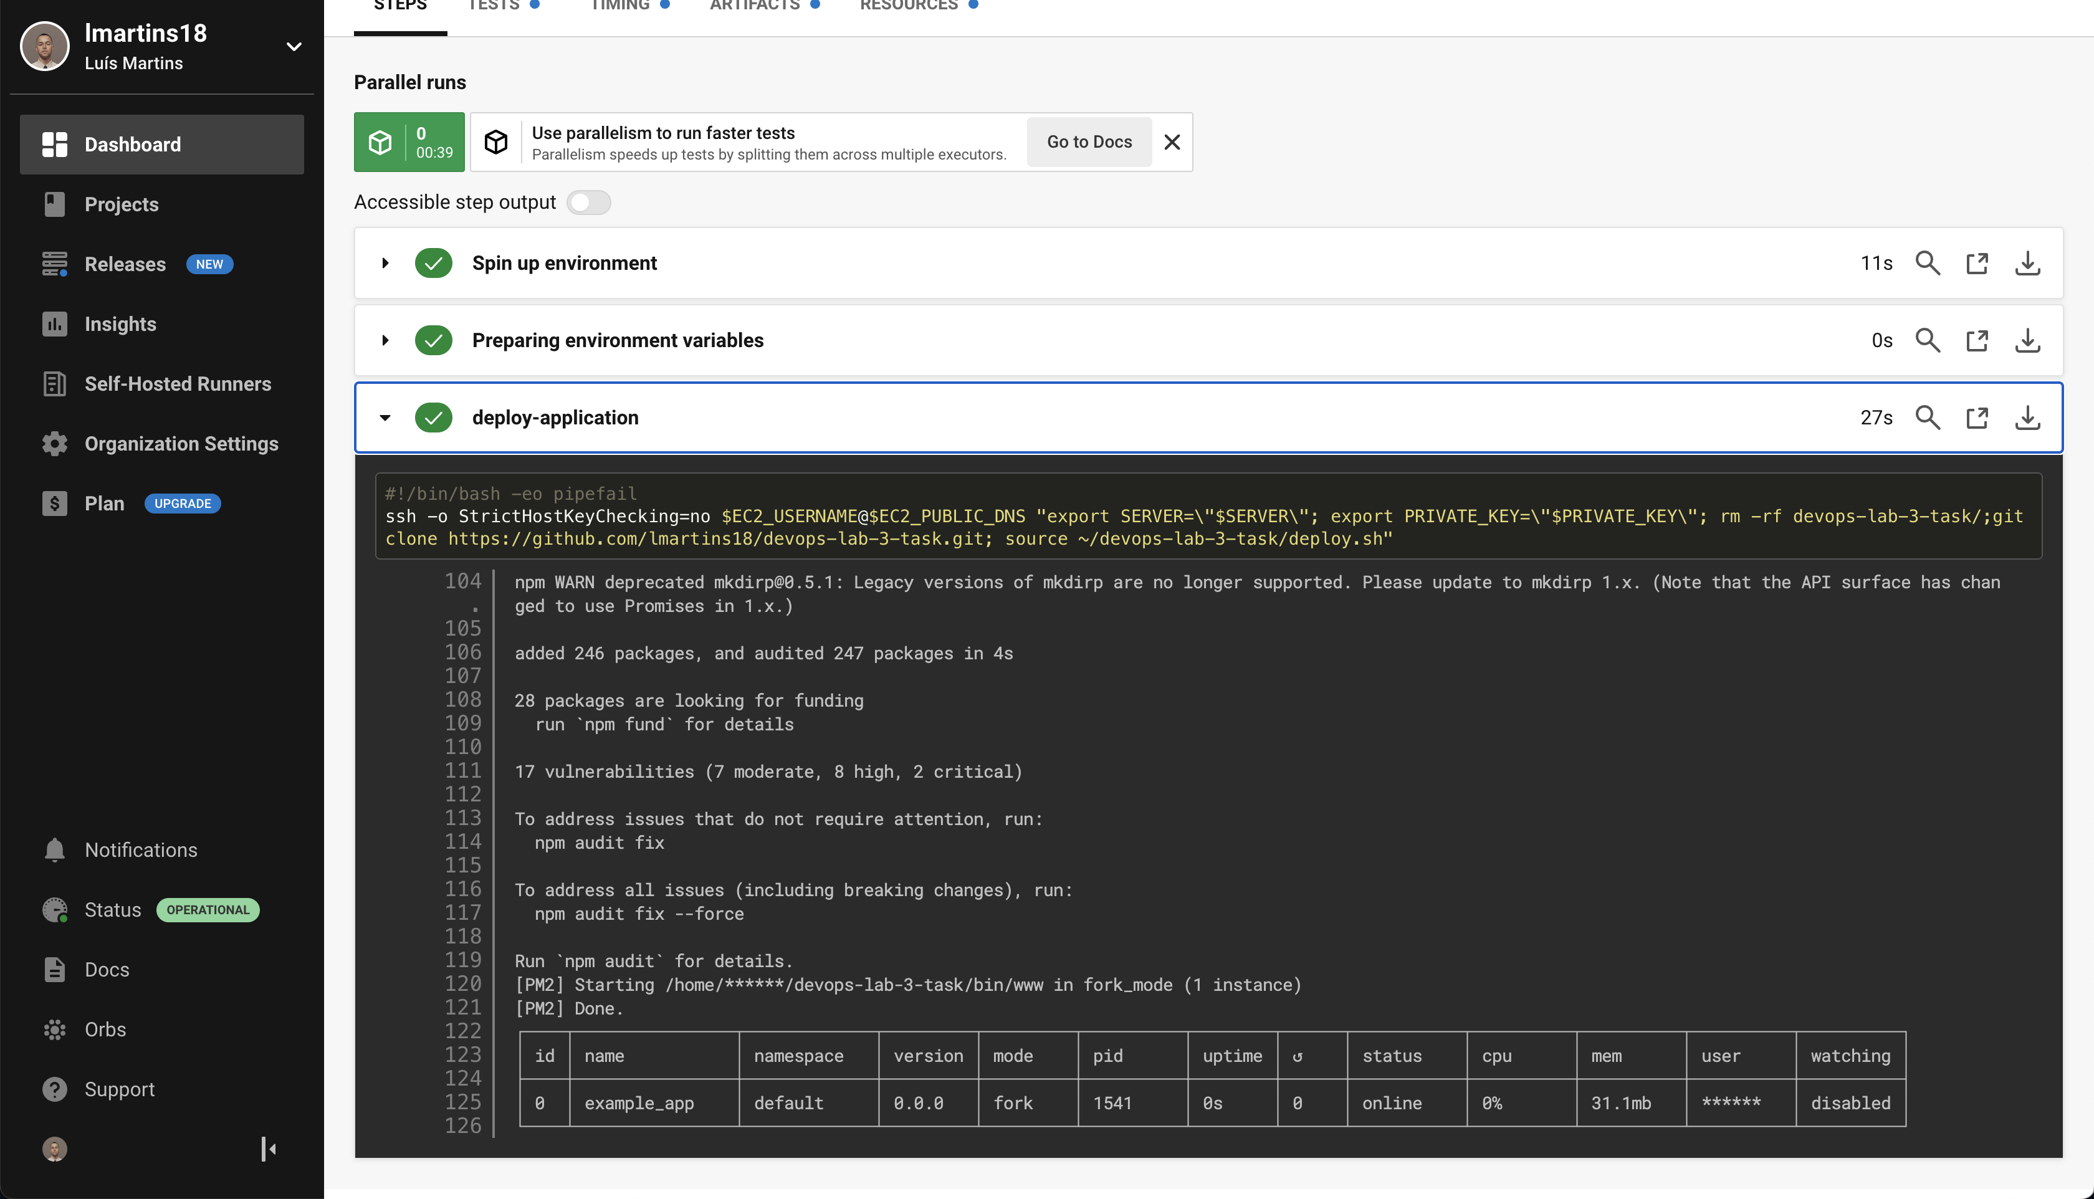

CircleCI last build, with new environmental variables passed.

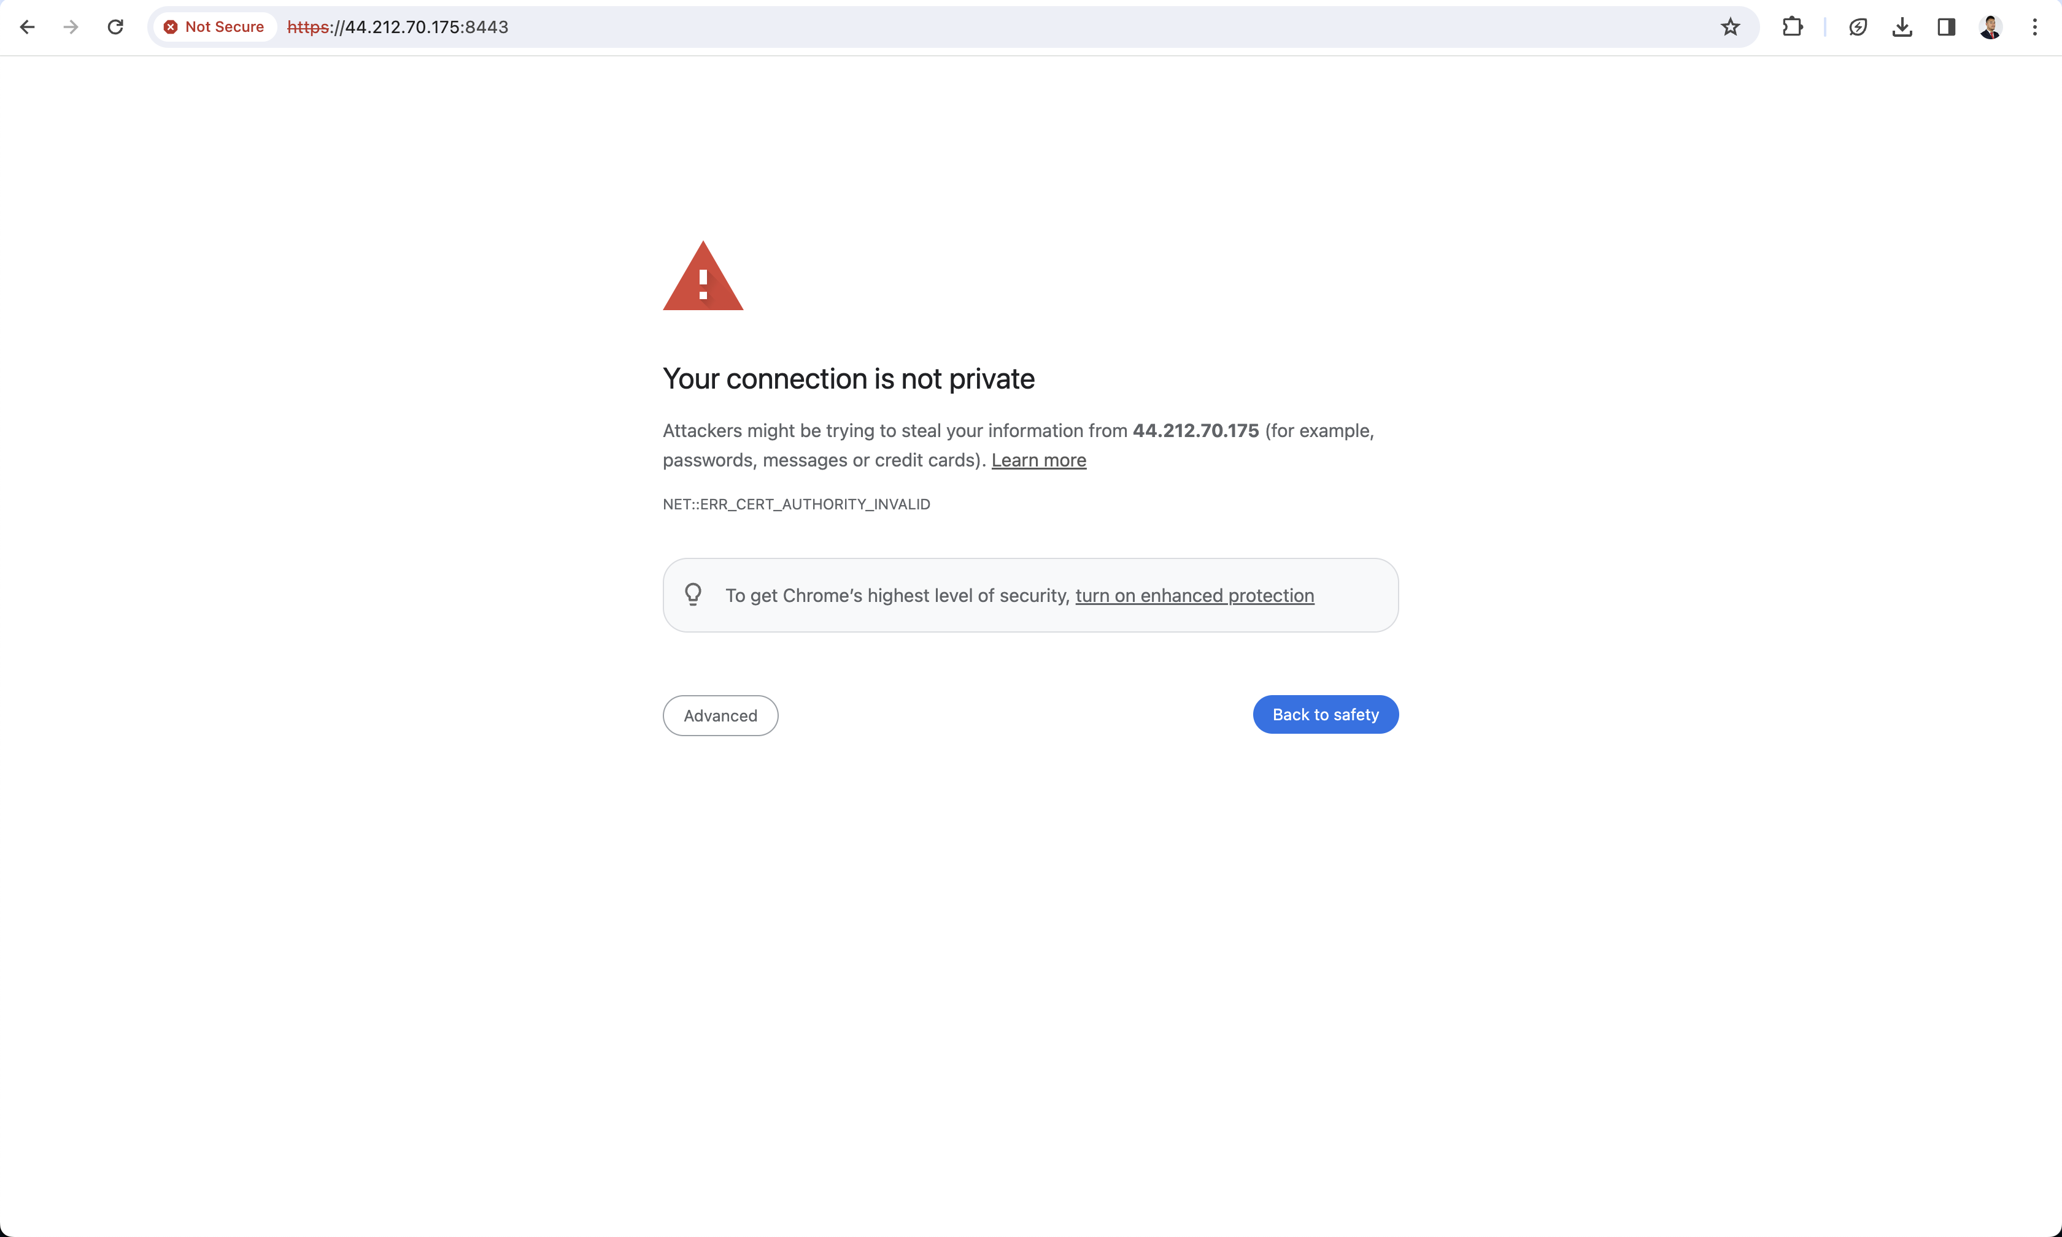

Access EC2 url on https port

